PHY 120
Bohr’s Hydrogen Atom Simulation
Lab
RL-APPLING ANDREW (RALEIGH)
1/22/2013

Objective: Understand the energy levels as related to Bohr’s hydrogen atom found at http://www.walter-fendt.de/ph14e/bohrh.htm.

Introduction
This lab is an attempt to explain the different energy levels of an atom and understand that a photon is either emitter or absorbed when an electron makes a transition from a higher to lower energy level. The energy level, the frequency, the wave length, the energy difference can all be calculated.
The simulation illustrates a hydrogen atom according to either a particle or wave model. The quantum number N is selectable and the orbit of the particle of the wave can be selectable with the mouse. If the orbit is in-between two levels this results in a non-stationary state. The energy levels were selectable from one to ten.
According to Bohr’s model, an electron emits no energy however, an electron which is not in its lowest energy level N1 can make a change to a lower state and thereby emit the energy difference in the form of a photon (particle of light). The lab states that by calculating the wave lengths of the corresponding electromagnetic waves one would get the same results as by measuring the lines of the hydrogen spectrum.
Description
- Bohr began with the assumption that electrons were orbiting the nucleus, much like the earth orbits the sun.
- From classical physics, a charge traveling in a circular path should lose energy by emitting electromagnetic radiation
- If the "orbiting" electron loses energy, it should end up spiraling into the nucleus (which it does not).
- Bohr borrowed the idea of quantized energy from Planck
  - He proposed that only orbits of certain radii, corresponding to defined energies, are "permitted"
  - An electron orbiting in one of these "allowed" orbits:
    - Has a defined energy state
    - Will not radiate energy
    - Will not spiral into the nucleus
If the orbits of the electron are restricted, the energies that the electron can possess are likewise restricted and are defined by the equation: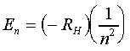
Where RH is a constant called the Rydberg constant and has the value 2.18 x 10-18 J.
Referenced from: http://www.mikeblaber.org/oldwine/chm1045/notes/Struct/Bohr/Struct03.htm

The formulas for energy difference, wave length, and frequency were also used to calculate and verify results in the simulation.
ΔE = Ef – E
i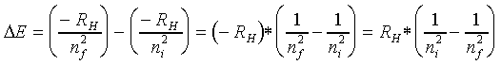
Frequency = ΔE/H

Results
N1=-2.179 x 10^-18 = -0.85 eV
N2 = -5.45 x 10^-19=-3.40 eV
N3=-2.42 x 10^-19 = -1.51 eV
N4 = -1.36 x 10^-19 = -0.85 eV
N5 = -8.7 x 10^-20 = -0.54 eV
N6 = -6.1 x 10^-20 = -0.38 eV
Graph of plotted energy values (y-axis) versus the quantum number n (x-axis).
The energy levels are separated. The calculated wavelengths for the transitions to n =2 (Balmer Series) were calculated using the formula $\frac{2^{2}x}{RH}\frac{ni^{2}}{(ni^{2}- 2^{2})}$ :
Example:
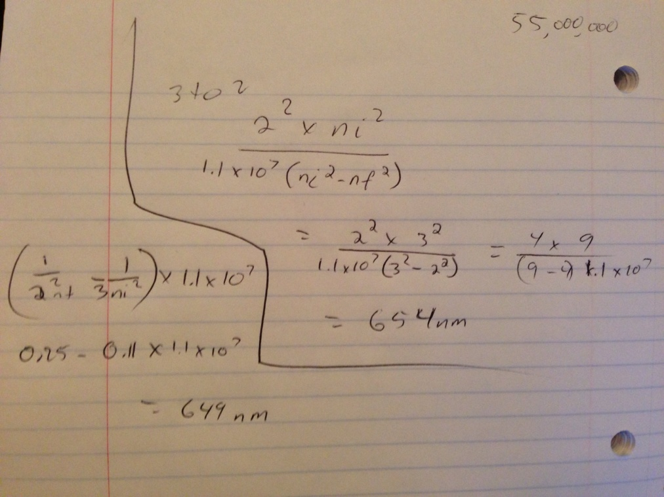
3 to 2 = 654nm
4 to 2 = 484nm
5 to 2 = 432nm
6 to 2 = 409nm
These spectrums correspond to wavelengths of visible light. According to my calculations the colors emitted are red and orange. However I am unsure of the accuracy of the calculation method used for this section.

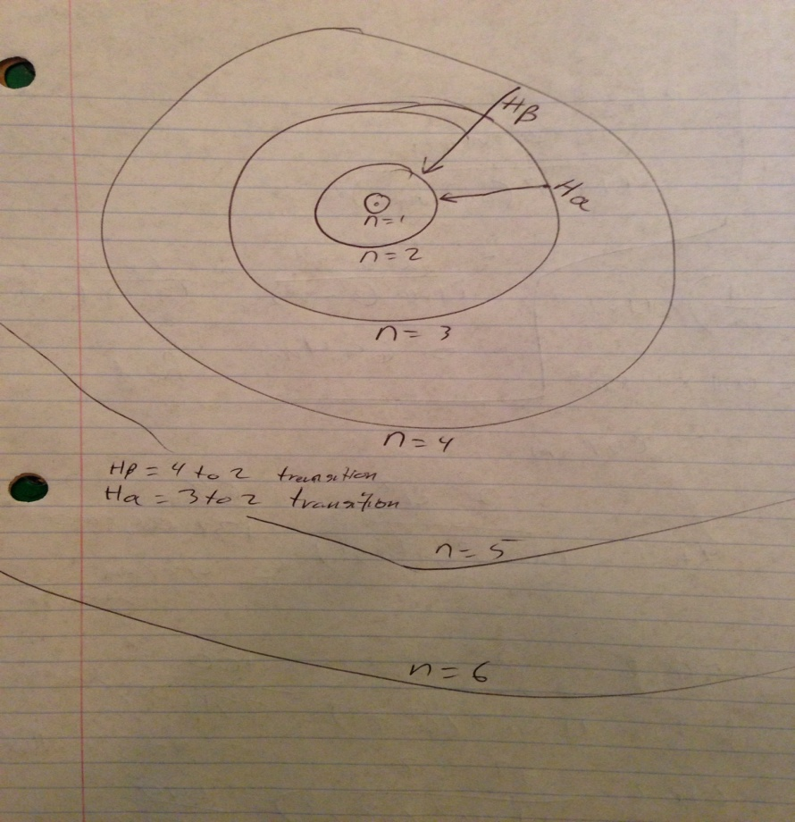
Conclusion
This lab was an excellent demonstration of the Bohr model of a hydrogen atom. It demonstrated the different energy levels and how an photon emitted is related to its change in transition as well as its relation to frequency and wavelength. The example calculations show and verify how different parts of the electromagnetic spectrum can be calculated and predicted.

